Material Transfer Agreement Information Sheet
Indiana University as Provider
Please enter the following information:

Principal investigator name: Michael VanNieuwenhze Department: Chemistry
Address: Department of Chemistry, 800 E. Kirkwood Ave., Bloomington, IN 47405-7102
Phone: 812-856-7545 Fax: 812-855-8300 E-mail: mvannieu@indiana.edu
Assistant / contact person name: Jim Lewis
Address: Department of Chemistry, 800 E. Kirkwood Ave., Bloomington, IN 47405-7102
Phone: 812-855-5706/812-855-9364 Fax: 812-855-8300 E-mail: chempool@indiana.edu
Recipient organization name:
Recipient contact person name:
Address:
Phone: Fax: E-mail:
Please answer the following questions:

- 1. | Please describe / identify the material and a brief description of the research you have done with the material: A reagent for fluorescent labeling of bacterial cell walls.
- 2. | Did you create this material? X Yes No If no, please explain the source:  - Please identify any obligations, restrictions on the use or transfer of the material, if known: None  - If your material was created using materials from another laboratory at IU, another university, a company collaborator, a commercial vendor, etc. (for example, commercially-purchased vectors, an antibody from a colleague), please identify the source:  - Is the material accompanied by patient identifying information? Yes X No
Was the research in which the material was created or made supported by funds from an external source? X Yes No
If yes, please identify the source: Grant from the National Institutes of Health (GM113172)

 | Are you working with the Indiana University Research and Technology Corporation (IURTC) Office of Technology Transfer on anything related to this material? (other than the current MTA) X Yes No
Do you wish to be compensated for the transfer of this material? Yes No
If yes, please provide your proposed transfer fee:

 | Please include any additional information that would aid us in processing this agreement: None
I acknowledge that the information provided herein is true and complete.
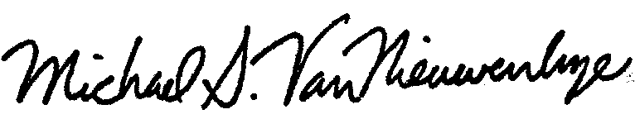
Investigator signature: Date:

